**INTRODUCTION TO HTML**

**(BASIC CONCEPT, CODE**

**AND SYNTAX)**

**LAB # 07**



**Fall 2021**

**CSE101L Computer Fundamentals Lab**

Submitted by: **Ali Asghar**

Registration No. :21PWCSE2059

Class Section: **C**

“On my honor, as student of University of Engineering and Technology, I have neither given nor received unauthorized assistance on this academic work.”



Student Signature: ______________

Submitted to:

**Engr. Abdullah Hamid**

March 12, 2022

Department of Computer Systems Engineering

University of Engineering and Technology, Peshawar

**LAB TASKS**

**Task 1:**

Create an HTML Web Page with the name “My Essay”. The page must have everything aligned

to the center, it must have your Name as the title and registration number as subheading

(smaller heading) underneath the heading. Then write a short essay (at least 100 words) about

any topic you like, you should apply bold, italic and underline in the paragraph and insert at

least two pictures about the topic. At the end of the page there should be an email link as well.

The page must have the following elements in use:

Title

Heading

Paragraph (should have different font and font size +3)

Image (multiple images related to your topic)

Email/link

Font

Background image/color

Text color

Bold/italic and underline

**CODE SCREENSHOT:** 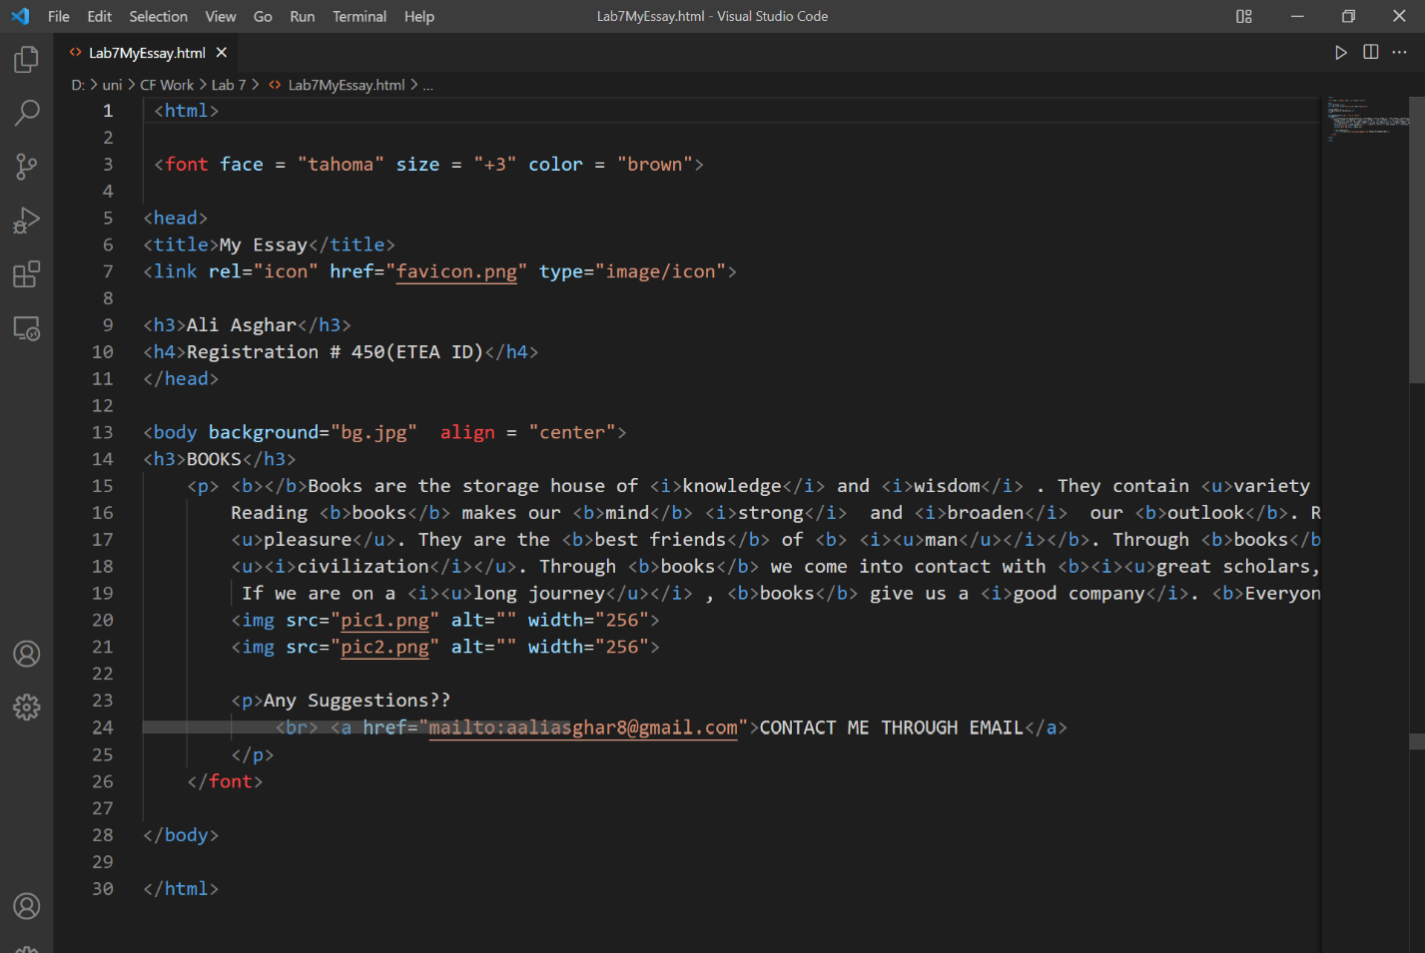

**OUTPUT:** 